Pooja Chopra, Adrian Seguro, Sandra Tacina

Project Background

We want to look at the famine crisis and Yemen and look at the various steps that lead to it such as U.S airstrikes and anti-civilian protests and visualized how they contributed to the famine and cholera outbreak.

Link to Datasets

Cholera Data:

<https://data.humdata.org/dataset/yemen-cholera-outbreak-daily-epidemiology-update>

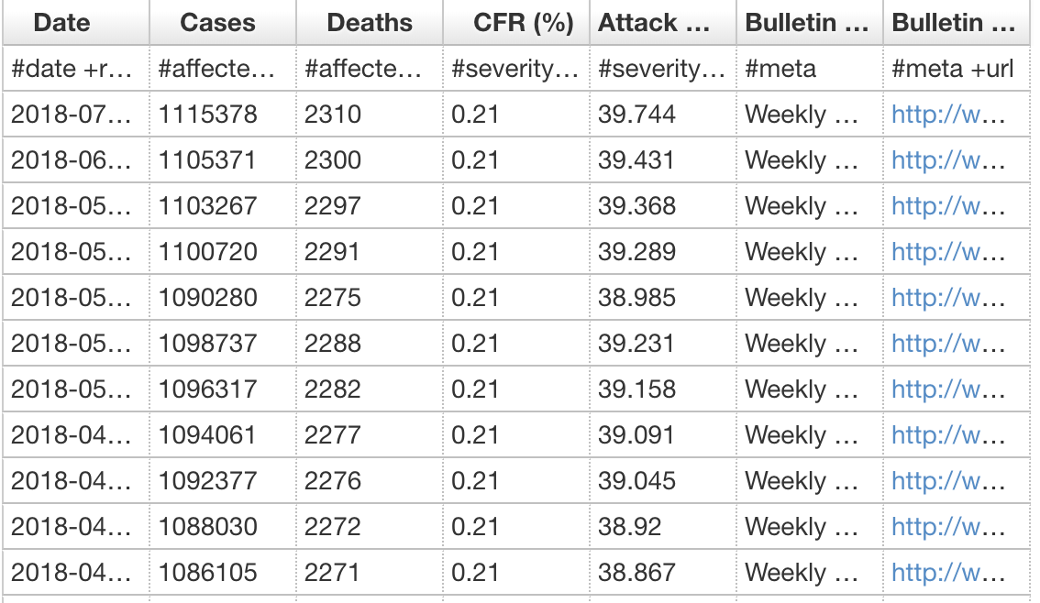

Airstrike Data:

<http://yemendataproject.org/data/>

Food Price Data:

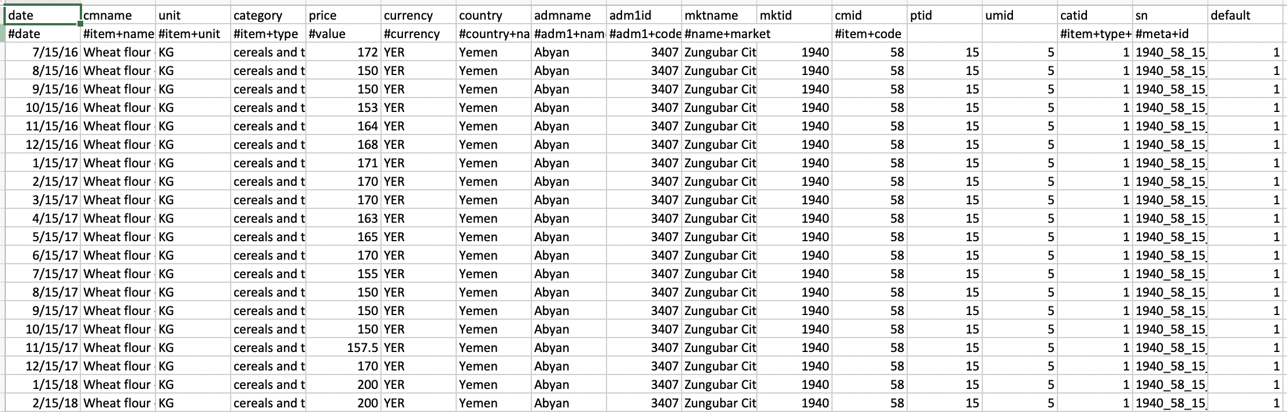

Inspiring Visualizations

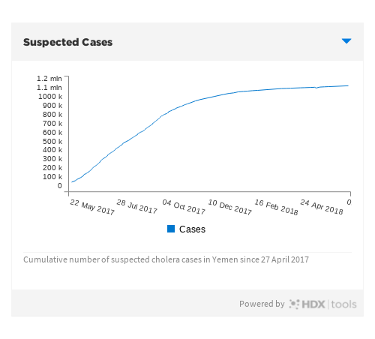

Sketch of Final Design

* Back story
* Airstrikes - map markers
* Anti-civilian Protests - heat map
* Cholera outbreak - aggregated numbers in regions
* Food prices - plot\
* GDP
* Use time to show development
* Baseline → Now → Projected
* Web Scraping News Articles

Link to primary Github repository

<https://github.com/PoojaChopra123/Project2.git>